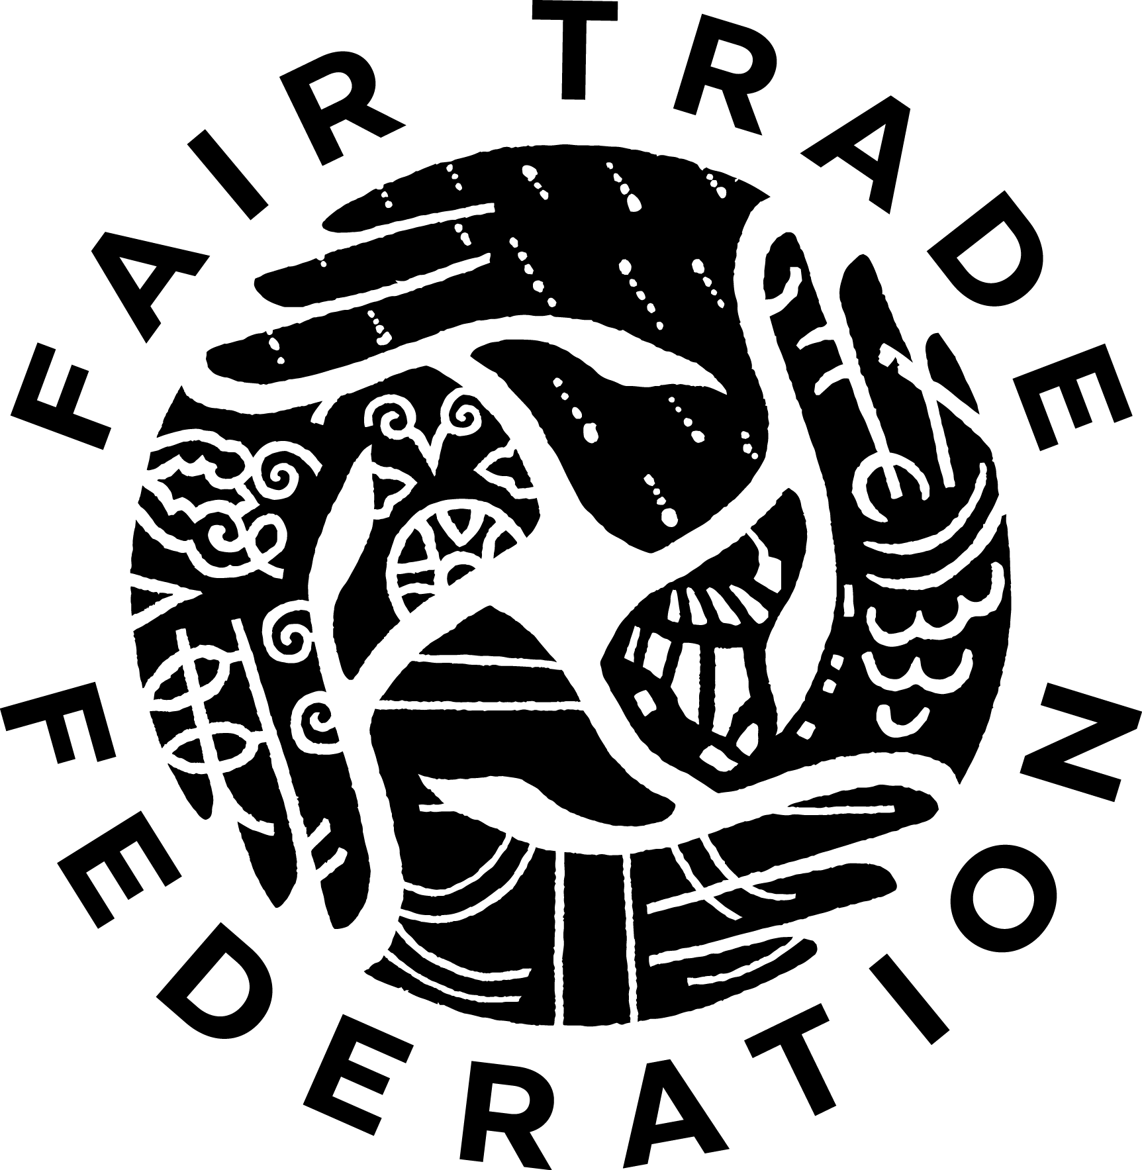

**Membership Application**

Handmade Products: Buying Directly from Producers

FTF Membership Manager contact information:

screening@fairtradefederation.org

302.655.5024

**Prepare for Screening**

*Before spending time on the application, read the* [*Fair Trade Federation Code of Practice*](http://www.fairtradefederation.org/fair-trade-federation-code-of-practice/) *to become familiarized with eligibility and sourcing requirements and the nine fair trade principles.* Applying to the Fair Trade Federation (FTF) is a rigorous self-reporting process during which applicant businesses must demonstrate outstanding work in all nine of the fair trade principles. A high level of transparency and detail is required on the FTF Membership Application. The onus is on applicants to demonstrate due diligence in ensuring fair trade partnerships.

*The FTF Membership Manager acts as liaison to the FTF Screening Committee and guides applicants through the screening process.* The FTF Membership Manager reviews submissions for missing components and information. Applicants will receive follow-up questions to clarify information before an application is reviewed by an FTF Screening Committee. It takes approximately 2 to 4 months from the time all components of the application are submitted to receipt of a final membership decision. However, no amount of time is guaranteed.

*Application materials are confidential.* By submitting application materials, the applicant affirms all information provided is true and presents business practices for review by FTF Screening Committee members and FTF employees. The applicant acquiesces to the FTF Screening Committee’s decision about FTF membership. The applicant maintains the right to appeal the decision through established procedures.

**Application Checklist**

Submit application materials to screening@fairtradefederation.org. All application components may be submitted separately and at different times, as reasonable. Where possible, please submit documents in pdf file formats.

**Narrative Questions** – Please send this document electronically.

**Financial Statement** - Please submit a profit & loss statement for your business’s most recent fiscal year. It may be unaudited.

**Producer List** - Please include a complete list of your business’s producer partners (including both artisan partners and wholesale suppliers as applicable). Include any affiliation a producer partner may have with a fair trade business (e.g. membership in FTF, World Fair Trade Organization, Fair Trade Forum India, etc). For all producers/suppliers that are not FTF or World Fair Trade Organization members, please include direct contact information.

**References** - Each individual who agrees to serve as a reference must complete a reference form (download forms [here](https://www.fairtradefederation.org/application-forms/#1532119155601-e0abd71b-b7a0)) then submit it directly to the FTF. Applicants are responsible for contacting one producer and two general references and ensuring they submit the completed forms. General references should not be employed by or currently volunteering for the applicant business. The FTF may contact individuals who submit a reference if additional information is needed.

**$85 (USD) Screening Fee** - Please mail a check payable to Fair Trade Federation or pay with a credit card [here](http://www.fairtradefederation.org/make-a-payment/). The screening fee is not refundable.

**Supporting Documentation** – Applicants are encouraged to submit documentation illustrating fair trade practices or other information about the business (e.g. cost analyses, contracts, impact assessments, contracts, continued improvement plans, news articles, product tags, annual reports, photos, etc.). Electronic submission is strongly preferred. Any physical items mailed to the FTF office will not be returned.

**Thank you for applying; we look forward to learning about your work.**

**Section 1: Business Information**

Registered legal name of business:

Public name of business:

Business website:

Contact person for this application:

Name:

Phone:

Email:

Business address:

City:

State/Province:

Postal Code:       Country:

Mailing address:  same as address above

Mailing address:

City:

State/Province:

Postal Code:       Country:

Preferred *public* telephone:

Preferred telephone for FTF contact:

Preferred *public* e-mail:

Preferred e-mail for FTF contact:

1. How did your business learn about the Fair Trade Federation?

1. Indicate your primary sales channel. *Choose one.*

Wholesale

Retail

Comments:

1. Indicate which product categories your business carries:

Food/Drink

Clothing

Jewelry

Accessories (e.g. bags, hats, scarves)

Bath/Spa

Housewares (e.g. tableware, linens, baskets, décor)

Furniture/Rugs

Paper Products (e.g. cards, stationary, labels)

Children’s Items

Musical Instruments

Do-It-Yourself Items (e.g. craft kits, fabric, loose beads, yarn)

Religious Items

Drop Shipping

Private Label

Other:

1. What is the legal standing of your Canadian/USA business?

For-profit corporation

Non-profit corporation

Sole Proprietorship

Cooperative

Other:

1. Does your business report sales to a taxing authority in Canada or the USA?

Yes  No

* 1. If no, explain.

1. Describe the structure and staffing of your business. Include the number of staff/volunteers located in the USA or Canada and their roles and responsibilities.

1. If your business is a trading branch within another business, describe their relationship.

1. If your business is structurally tied to an entity based outside of the USA/Canada (such as a producer group) or shares a name with one, describe the relationship, including information about governance.

1. Does your business pay for products received?

Yes  No

* 1. If yes, what are the terms of payment?

1. How long has your business been in operation? Note: Businesses must be in operation for *at least 365 days and experience a full production and sales cycle* before applying for FTF membership.

1. When is your business’s fiscal year?

1. How much did your business earn in gross sales of merchandise (in USD) during the last fiscal year?

1. In which ways does your business wholesale products? Indicate all that apply.

Trade shows

Website

Sales reps

Other:

1. In which ways does your business you retail products? Indicate all that apply.

Brick & mortar location

Mobile sales (e.g. fairs, festivals)

Website

Direct sales (e.g. home parties, sales ambassadors)

Other:

**Section 2: Self-Assessment**

1. If your business has a mission statement, provide it here.

1. Why does your business choose to operate using fair trade practices?

1. Why does your business want to be a member of the Fair Trade Federation?

1. In which areas related to the fair trade principles does your business excel and why?

1. In which areas related to the fair trade principles is your business most challenged and why?

1. What goals related to continued improvement of fair trade practices would you like your business to achieve in the next five years?

**Section 3: Vetting Producers**

**3.1 Products Sourced Directly from Artisans/Producers**

1. What information does your business gather about artisan/producer groups or individuals before buying products?

1. How does your business decide with which artisans/producers to work? Attach sample questionnaires/evaluation forms used in this process. Describe the decision-making process in detail.

1. Does your business purchase items produced in Europe, the USA, or Canada?

Yes  No

If yes:

* 1. What percentage of the wholesale value of your business’s inventory do these products represent?

* 1. Explain how the above products are sourced according to the fair trade principles.

1. Excluding those mentioned above, does your business purchase any products that are not sourced according to the fair trade principles?

Yes  No

* 1. If yes, describe why they are purchased.

1. Does your business sell used items or antiques? This includes antique items and any product made with used/antique components or raw materials.

Yes  No

If yes:

* 1. Describe how they are sourced.

* 1. How does your business ensure any used or antique components do not violate international cultural heritage laws?

**3.2 Products Sourced From Wholesale Suppliers**

1. Does your business purchase any products from wholesale suppliers?

Yes  No

*If no, skip to Section 4.*

1. Are at least 75% of retailed products - *as measured by wholesale value of inventory* - sourced according to fair trade principles? Note: This may include Fair Trade Federation or World Fair Trade Organization (WFTO) member products *and* any other products that *your business has vetted* for the fair trade principles.

Yes  No

* 1. What percentage of products is purchased from FTF or WFTO member businesses (measured by wholesale value of inventory)?

* 1. What percentage of products is purchased from non-member fair trade businesses (measured by wholesale value of inventory)?

1. Does your business purchase any of the following products from wholesale suppliers:

educational products (e.g. books, music, maps, etc.)

products from local or small-scale producers in the USA, Canada, or Europe

environmentally friendly products

any other products purchased from businesses that do not follow fair trade principles

none of the above

*If none of the above, skip to Section 4.*

* 1. What percentage of the wholesale value of your business inventory do these products represent?

* 1. Explain why your business sources these products.

* 1. How does your business ensure these products do not harm people, the environment, or cultures?

**Section 4: Creating Opportunities for Economically and Socially Marginalized Producers**

1. Provide a detailed summary of the communities in which your business’s artisan/producer partners live.

Include information like average incomes and cost of living, government-regulated minimum wages, adult education levels, existing options for earning income, and general living conditions. Use as much detail as possible.

If your business works in several or many varying regions, include multiple examples that are representative of the full range of artisan/producer partners.

**Section 5: Support Safe and Empowering Working Conditions**

**5.1 Support Safe and Empowering Working Conditions Among Artisan/Producers**

1. Describe the structures of leadership and governance among the artisans/producers with whom you work.

1. Describe how individual artisans/producers contribute to and participate in decision-making.

1. Do staff members of your business communicate directly with *individuals* who make products?

Yes  No

1. How does your business create secure ways for *individual* artisans/producers to address concerns or grievances?

1. Does your business require artisans/producers to participate in any religious activities?

Yes  No

* 1. If yes, describe.

1. Describe in detail the facility(ies)/location(s) at which artisans/producers work.

1. How does your business evaluate production processes for health and safety risks?

1. What risks have been identified since your business began operating?

1. How has your business addressed any risks?

1. How often does your business reassess production processes for health and safety risks?

**5.2 Support Safe and Empowering Working Conditions in Canada/USA**

1. Describe how your business’s staff (including volunteer staff) participate in decision-making.

1. Describe opportunities for staff advancement and growth.

1. Describe in detail the facility(ies)/location(s) in which any staff work.

1. How does your business ensure a healthy and safe workplace for all staff?

1. Describe your business’s established procedures for all staff to securely address concerns and grievances.

1. Does your business have a written non-discrimination policy?

Yes  No

* 1. If no, why not?

* 1. If yes, how is this shared with staff/employees in your business?

1. If your business works with independent contractors, briefly describe their role(s).

**Section 6: Build Capacity**

1. Describe goals your business would like to help artisan/producer partners achieve in the next five years.

1. Describe ways your business collaborates with other businesses and non-governmental or fair trade organizations in artisan/producer communities.

1. How often do staff members from your business visit the artisan/producer partners?

1. How long has your business worked with its current artisan/producer partners?

1. When your business begins a buying relationship with artisan/producer partners, how long does the partnership typically last?

1. What would cause your business to stop purchasing from an artisan/producer partner?

1. If your business has ended any purchasing relationships with artisan/producer partners, explain why and how it was handled.

1. Indicate all the following services or assistance to which artisans/producers have access through your business:

Advance Payment

Bonuses

Credit

Dividends

Schooling

Financial Management

Grants

Loans

Business Development

Product Design

Product Development

Technical Training

Other:

1. Provide specific examples of your business’s success in implementing one or more of the services indicated above.

1. How does your business evaluate the impact of its partnership on the lives of artisans/producers over time?

**Section 7: Develop Transparent and Accountable Relationships**

1. Describe in detail the process by which your business plans and makes purchases from artisan/producer partners.

* 1. If using purchase orders, submit a copy.

1. How do artisans/producers provide input for the design and ordering processes?

1. How often does your business’s staff communicate with artisan/producer partners?

1. What methods does your business use to maintain contact with artisans/producers?

1. What information about your business is shared with artisan/producer partners? Be specific.

1. Does your business buy products on consignment?

Yes  No

If yes:

* 1. Explain why items are purchased on consignment.

* 1. What percentage measured by the wholesale value of inventory is purchased on consignment?

1. When sales increase, how does your business ensure artisan/producer partners are prepared to meet greater demand?

1. When a product is not selling as well as expected, how does this affect your work with artisan/producer partners?

1. Do the artisans/producers with whom you work have job security?

Yes  No

Why or why not?

**Section 8: Respect Cultural Identity**

1. How has your business incorporated or embraced artisan/producer partners’ cultural traditions?

1. In what ways are artisan/producer partners’ traditional production techniques incorporated into product development?

1. How does your business source marketable products without diminishing traditional/cultural techniques or identities?

**Section 9: Pay Promptly and Fairly**

**9.1 Pay Promptly and Fairly: Costing**

1. Provide a cost breakdown for one of your popular products showing costs in numbers for the entire supply chain from raw materials to customer price.

1. If artisans/producers set their own prices, explain in detail their methods for determining fair prices for their work.

1. If your business and artisans/producers work together to determine prices, describe the process in detail. Attach any worksheets or other tools used to show how product prices are determined (e.g. cost analysis worksheets).

1. How often does your business re-evaluate pricing?

1. How have pricing methods changed over time?

1. What is the living wage in the communities in which the artisans/producers work? Include the pay period.

1. Since living wage can vary, describe which factors your business uses to determine living wage in the communities in which artisans/producers live and work.

1. What is the government mandated wage in the communities in which artisans/producers work, if any? Include the pay period.

1. How does your business determine the price at which products are sold to customers?

1. Do the artisans/producers who create the products your business buys understand how customer prices are established?

Yes  No

* 1. If yes, explain what methods your business uses to share that information.

**9.2 Pay Promptly and Fairly: Compensation**

1. Does your business have an advance payment policy?

Yes  No

* 1. If yes, describe the policy. If no, explain why not.

1. When do artisans/producers receive final payment for products?

1. Who purchases and gathers raw materials?

1. Does your business ever offer payment in goods, services, or other non-cash forms?

Yes  No

If yes:

* 1. Who determines whether cash or non-cash payments will be used?

* 1. How is the market value of non-cash-payments determined?

* 1. How do the market values of non-cash-payments meet or exceed a living wage?

1. At which rate are individual artisans/producers compensated (e.g. per hour, per piece, salary)?

1. Describe target compensation ranges from lowest to highest paid artisans/producers.

1. Do the artisans/producers with whom your business works currently receive a living wage?

Yes  No

* 1. If no, explain.

1. Describe the methods used to distribute wages to each individual artisan/producer.

1. How does your business ensure wage payments are distributed fairly?

1. Describe your business’s policies for cancelling orders.

1. Within the past year, has your business engaged in any disagreements with artisans/producers regarding payments?

Yes  No

* 1. If yes, explain the situation and how it was resolved.

1. If your business employs support staff in artisan/producer communities, how is their compensation determined and by which methods are they paid?

**Section 10: Ensure the Rights of Children**

**10.1 Ensure the Rights of Children Among Artisans/Producers**

1. What methods does your business use to determine whether and in what ways children under the age of eighteen are involved in production?

1. What are your business’s expectations regarding children’s involvement in production?

1. If any individuals under the age of eighteen play a role in production, explain why.

**10.2 Ensure the Rights of Children In Canada/USA**

1. Does your business employ anyone under the age of eighteen in Canada/USA?

Yes  No

* 1. If yes, explain how your business meets national, state/province, and local laws regarding the rights of children.

**Section 11: Cultivate Environmental Stewardship**

**11.1 Cultivate Environmental Stewardship in Production**

1. How does your business impact the health of the natural environment in artisan/producer communities?

1. How does your business evaluate production practices for environmental challenges or risks?

1. Describe how your business is addressing any environmental challenges or risks.

1. Does your business incorporate recycled or sustainably-grown materials into products?

Yes  No

* 1. If yes, describe. If no, explain.

1. Describe actions your business takes to source any raw materials in an environmentally sustainable manner.

1. How does your business meet existing laws regarding product safety testing?

**11.2 Cultivate Environmental Stewardship in Canada/USA**

1. How does your business impact the health of the natural environment in your Canadian/American community?

1. How does your business evaluate its operations for environmental challenges or risks?

1. How does your business incorporate sustainability into its facilities and operations?

1. Does your business incorporate recycling, reuse, and post-consumer recycled supplies into its operations?

Yes  No

* 1. If yes, describe. If no, explain.

**Section 12: Promote Fair Trade**

1. How does your business build links between producers and consumers?

1. How does your business share information about the fair trade principles with customers?

1. What information does your business collect about artisan/producer partners and how is it collected? Be specific.

1. How does your business use collected information in communication with customers? Be specific, and submit examples of product hang tags, packaging, literature, or any other relevant materials.

1. How does your business collaborate with other fair trade businesses and organizations in Canada/USA to promote fair trade and benefit artisan/producer partners?

**Section 13: Additional Comments**